Assignment 03

Cryptology – b keerthana

Amruthesh

241059041

M.E - Cyber Security

MSIS, MAHE

1. **Write a python script to encrypt the string using Caesar cipher.**

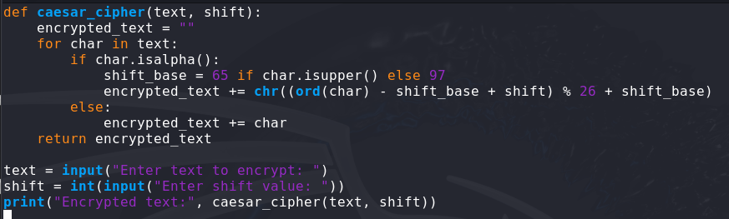

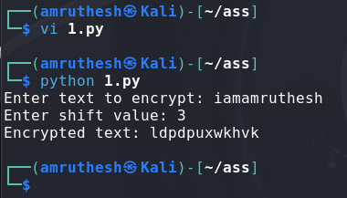

1. **Write a Python script to Modify the above script to shift cipher based on user choice.**

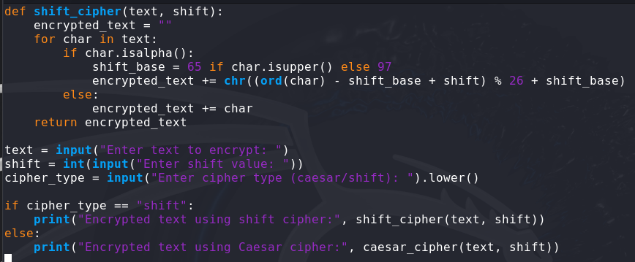

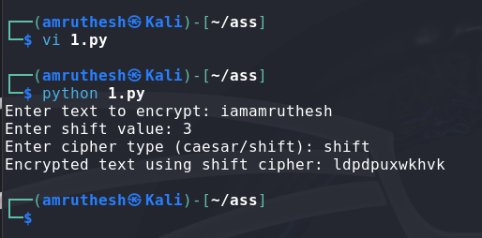

1. **Write a Python script to convert cipher text into uppercase characters and split the cipher into group of 5 of characters.**

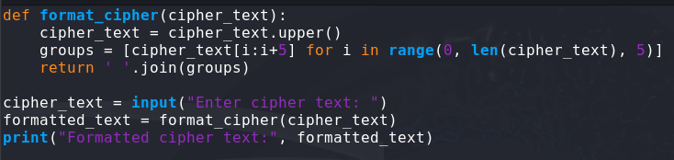

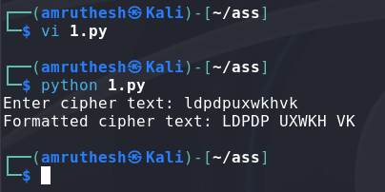

1. **Write a Python program to Find the histogram for each character.**

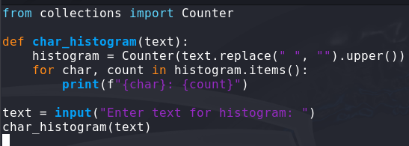

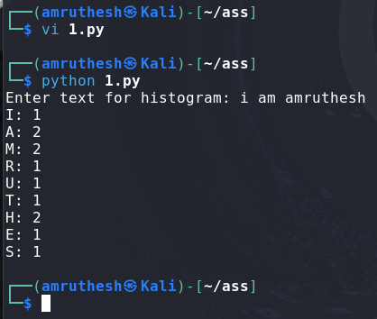

1. **Write a Python script to read the contents from the file.**

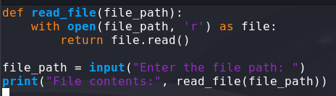 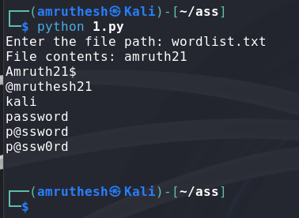

1. **Write a Python script to encrypt the contents from the file.**

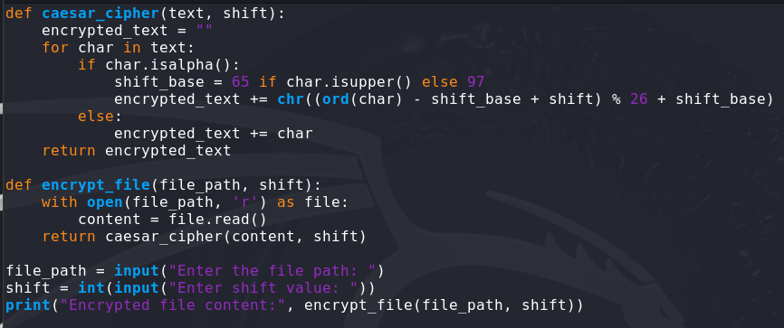

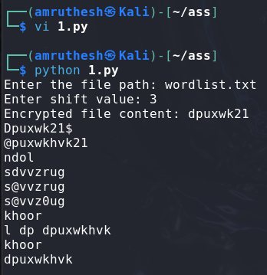

1. **Do validation to the python program (2)**

**- not to accept special characters**

**- not to accept numeric values**

**- not to accept empty value**

**- accept only string**

**- string should be lowercase if not convert the case**

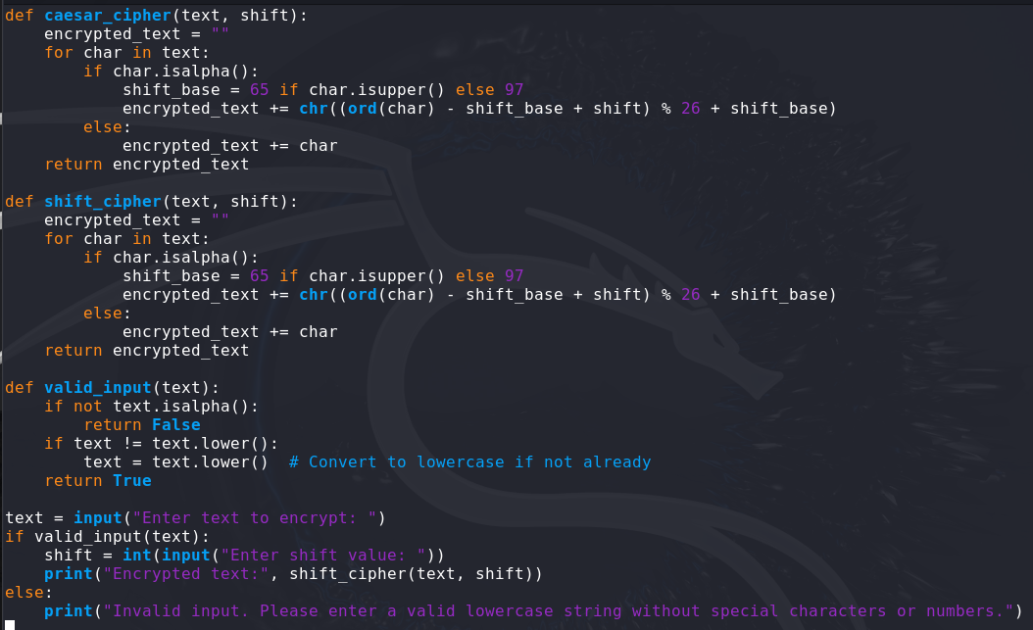

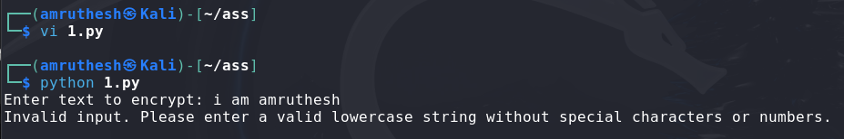

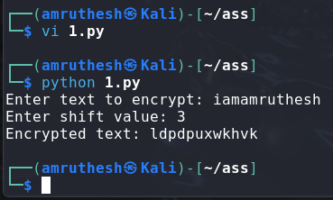

1. **Write a Python program to checks if two given strings are anagrams of each other. example:**

**mug, gum | cork, rock | note, tone**

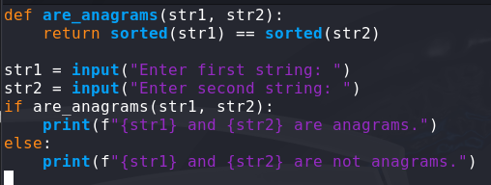

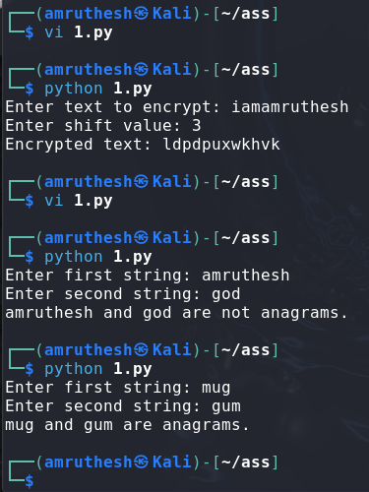

1. **Write a Python program to check the given string is palindrome or not.**

**Do not use built in functions.**

**Example:**

**MADAM, RACECAR, LEVEL, CIVIC**

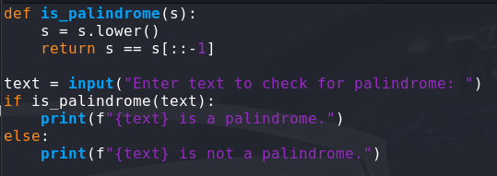 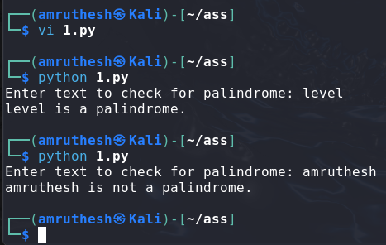

1. **Write a Python program to check if a substring is present in a given string.**

**Example: Understand – stand**

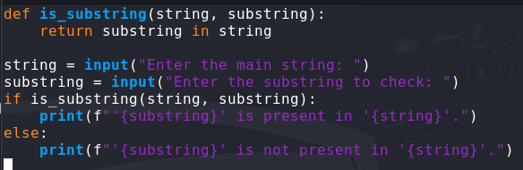 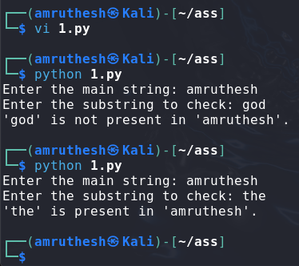

1. **Explore string module**

**import the string module in your python script.**

**print all the lowercase characters**

**print all the uppercase characters**

**print all the lowercase and uppercase characters**

**print all the digits**

**print all the punctuation symbols**

**count the total number of punctuation symbols**

